FY2025　Welcome Party

**Welcome Festival Stage**

Application Booklet

Registration Period:

Feb 24th (Mon) – March 8th (Sat)

Table of Contents

P.1　Cover

P.2　Table of Contents

P.3～6　Details of Stage Event

P.7～8　Process until Performance

P.9　About Using Sound and Prohibitions

P.10～11　About Registration

P.12　About Selection Meeting

P.13～14　About Organization Interview

P.15〜16　Privacy Policy

P.17　List of Required Documents

P.18　Contacts

Details of Stage Event at OIC

Dates and time: April 3rd (Thur) 12:10～13:10

　　　April 4th (Fri) 11:45～13:05

Place: SORA-NO-Plaza　Stage: Depth 2.6m × Width10.27m

　　　　　 Audience area: Depth 4m × Width 10.27m

※The performance time is subject to change.

※The size of the stage and the audience area can be changed as well.

【SORA-NO-Plaza】

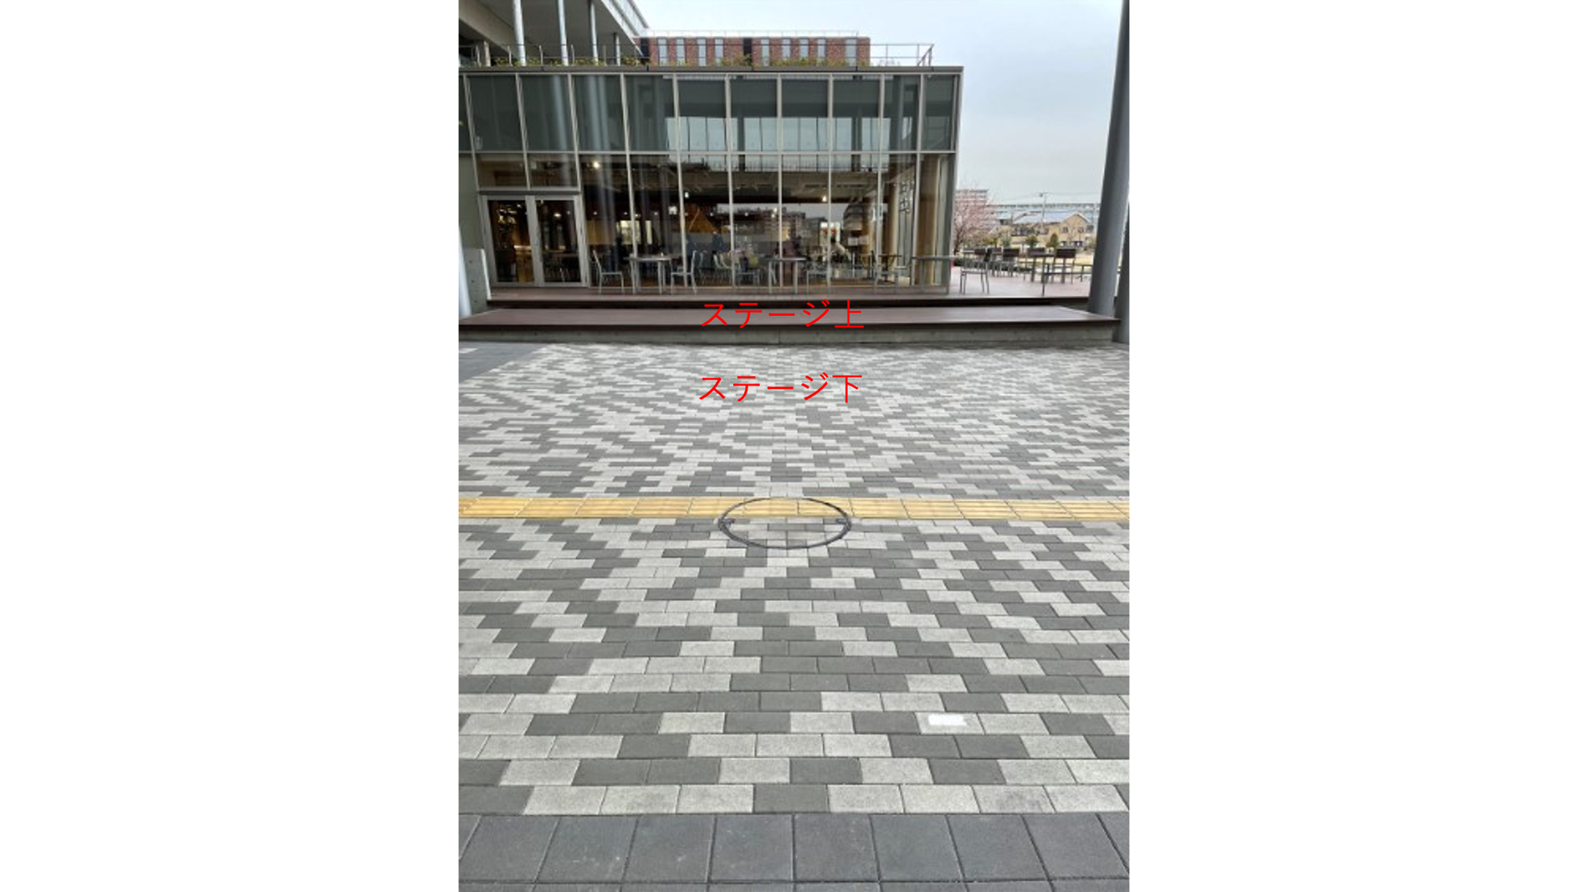

【Section Outline】

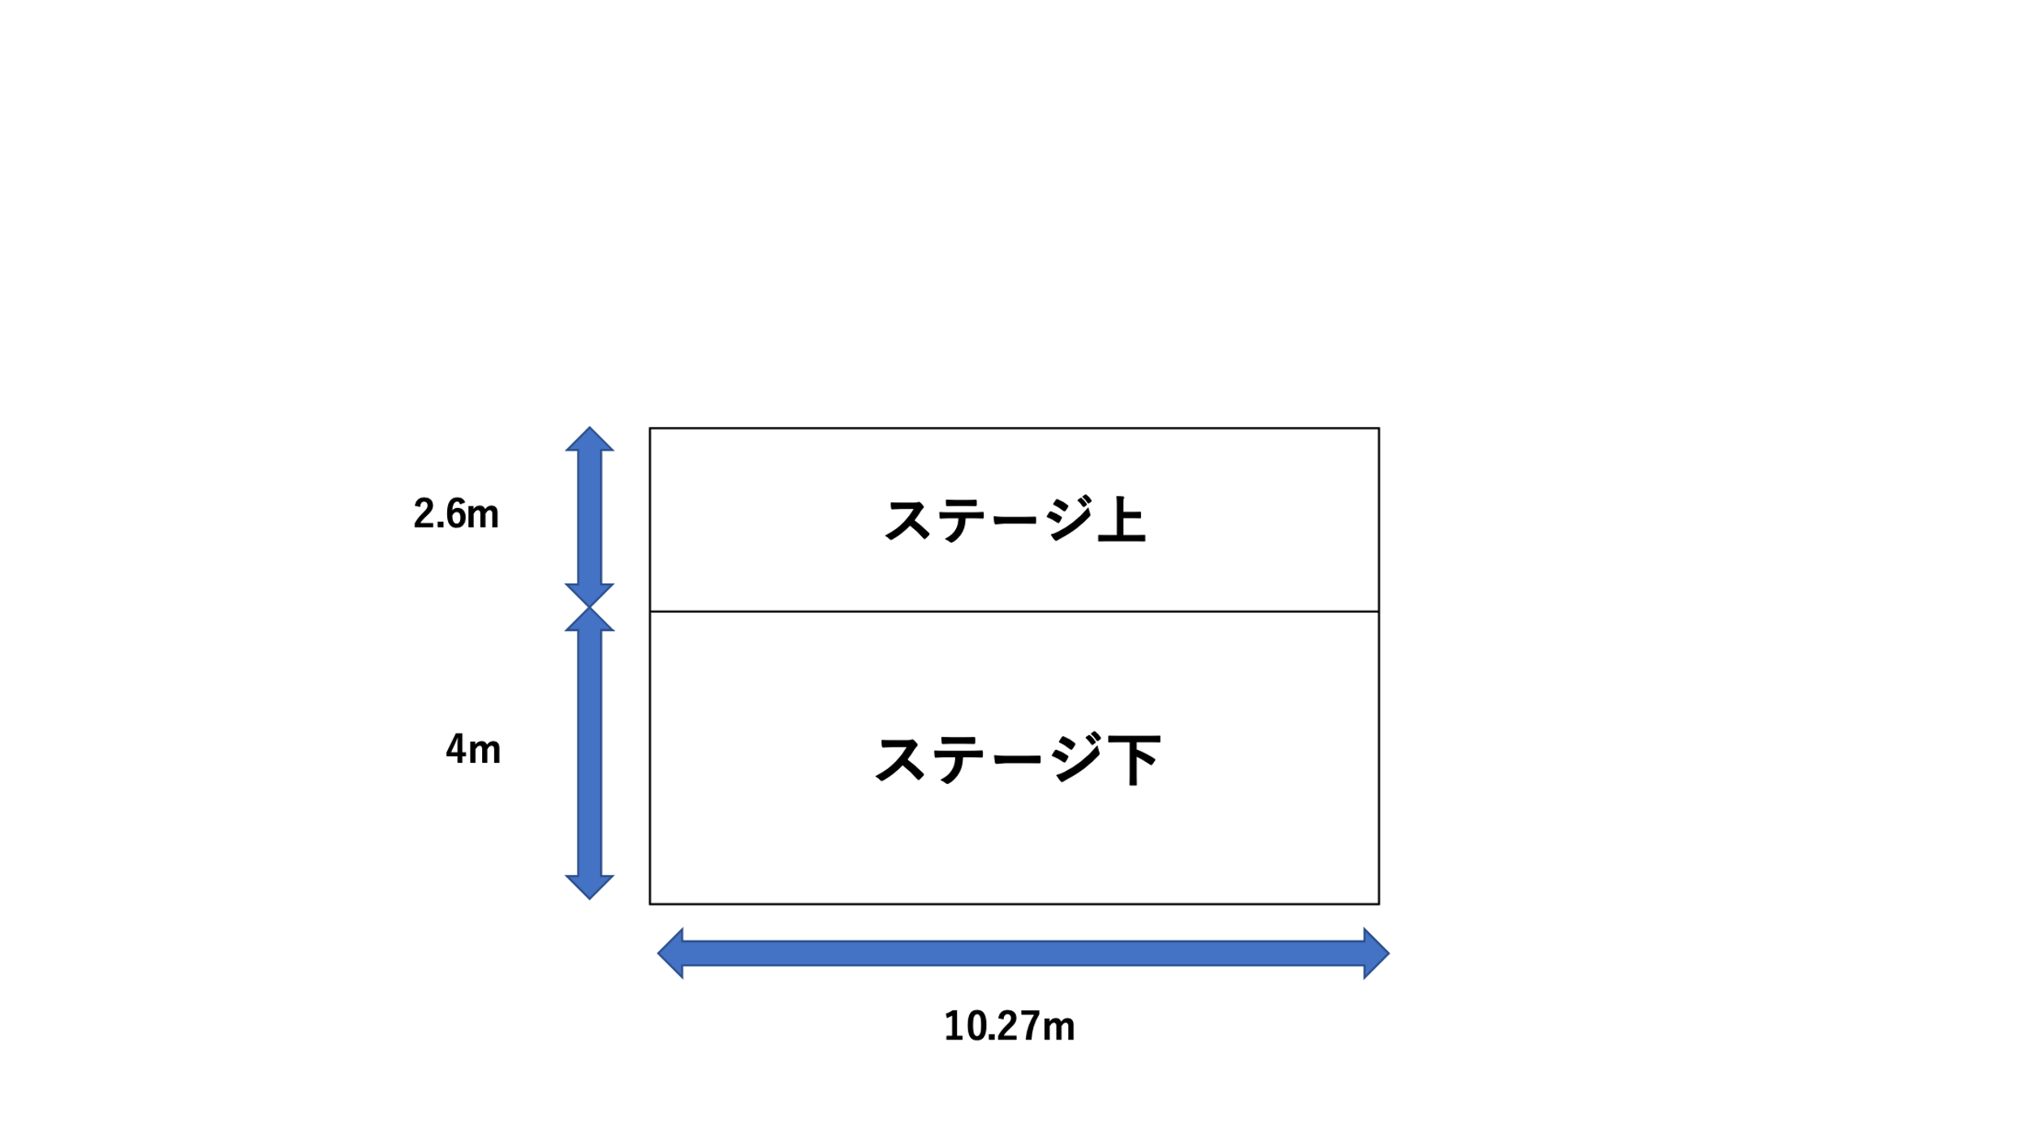

【About Registration】

・We only accept applications from performance organizations.

　※Please refer to About Using Sound section on P.9 for more information.

・The performance time is 10 minutes per 1 organization (NOT including the transition time).

・Available slot: 7 organizations

　※The number of available slots for performance groups may increase or decrease depending on the situation.

・Organizations which have already applied or plan to apply for the Welcome Festival Stage event at other campuses can also apply for this stage event.

**※Event managers and performers for the OIC stage event cannot participate in stage events at other campuses.**

【Qualifications】

1. The majority of the performers are Ritsumeikan University students.
2. The event manager is a Ritsumeikan University student.
3. Both the event manager and the participants of the stage events do not also serve as the event manager or participants in the Circle Booth Event, and the event manager in the Organization Flyer Event.
4. The organization belongs to the Ritsumeikan University Student Union (unregistered organizations are not accepted)

※The event manager and the organization leader cannot be the same person.

【About transition time】

・10 minutes of transition time is allocated for each organization.

**※The length of transition time may increase or decrease depending on situations.**

・Ritsumeikan University Broadcasting Center (RBC) will interview you before and after your performance.

・The content of the interview is provided on the organization interview pre-responce form. Please make sure to check it beforehand.

【In case of rain】

The stage event will be held even in case of rain, as the SORA-NO-Plaza has a roof. However, if it becomes difficult to carry out this event due to bad weather, the Ritsumeikan University Student Union Central Administrative Office University-wide Events Department (University-wide Events Department), RBC and the Ritsumeikan University Welcome Events Executive Committee (Welcome Events Executive Committee) will discuss the situation and make a decision on whether to cancel the stage event or not. If the weather worsens during the stage event (this event), the same decision-making process will be followed. If the Welcome Festival itself is cancelled, this event will also be cancelled. In either case, the performing organizations will be notified of the cancellation via the stage event official LINE.

Process until Performance

1. Registration　※Please refer to P.10-11 for more

Application period： February 24 (Mon) – March 8 (Sat)

Submission Location： Welcome Festival OIC Stage Event Application Google Form on the Student Union Website

1. Selection Meeting　※Please refer to P.12 for more

Date and Time： March 10 (Mon) 13：00～

Place： Student Lounge (Building A, 3rd Floor)

We will select the performing organizations in a selection meeting.

※Organizations do not have to attend the selection meeting, as we (University-wide Events Department and RBC) use videos submitted by the organizations to the Google Form in the meeting.

1. Announcement of the result of the selection meeting　※Please refer to P.12 for more

Date and Time： March 10 (Mon) 16:00～23:59

※We will notify the event manager and the organization leader of the result via email. Please make sure that the event manager and the organization leader can receive our emails.

※We will also send an email to the organizations which did not pass the selection process.

※We will attach the QR code of the official LINE to the email. Please make sure to add the account as a friend.

1. Organization Interview　※Please refer to P.13-14 for more

Dates： 1st interview - March 20 (Thur), March 21 (Fri)

　　　2nd interview – March 25 (Tue), March 26 (Wed)

The performing organizations will discuss the content or means of performance with the University-wide Events Department and RBC.

※The interviews will be held on Zoom (we will notify the event managers and the organization leaders of the Zoom link, etc. via email by the day before the interview).

1. Rehearsal

Date and Time： April 2 (Wed) 10：00～15：00

Meeting Place： SORA-NO-Plaza

Document to Submit： Written Oath (signed)

◎Organizations not using sound for their performance can only have a tech rehearsal in principle.

※Bluetooth speakers or smartphones can be used during the rehearsal. If using such equipment, please bring them by yourselves.

◎Organizations using sound include organizations which will play musical instruments or A Cappella circles. Please start and end your rehearsals strictly within the allocated time.

◎The rehearsal time is different for each organization. We will notify you of the details about the date and time in the organization interview.

◎If the rehearsal cannot be held due to bad weather or schedule conflicts, we plan to have rehearsals on the day of the Welcome Festival from 9 am. Changes on rehearsal schedules will be communicated via the official LINE.

1. Performance

Date and Time： April 3 (Thur) 12:10～13:10

　　　April 4 (Fri) 11:45～13:05

Place： SORA-NO-Plaza

◎On the day of the event, a staff member from the University-wide Events Department will escort you from the waiting room to the stage. When doing so, please bring your valuables with you, and have a designated person from your organization to manage valuables during performance. Tents for changing clothes during performances will not be provided.

　※Please make sure that each organization takes responsibility for managing the members’ valuables. The University-wide Events Department will not be responsible for lost valuables or any troubles regarding valuables (the university will not be responsible as well).

About Using Sound

At OIC, CD audio sources can be used during stage performances for the local residents.

As an exception, performances using musical instruments are allowed. If you wish to use instruments, please contact the University-wide Events Department beforehand.

Prohibitions

1. Actions or statements that defame, slander or insult others during the performance
2. Performance contents which violate public decency and order
3. Performances with religious or political contents
4. Damaging or breaking equipment on stage
5. Other actions or statements deemed inappropriate by the University-wide Events Department or Welcome Events Executive Committee

※If you violate these prohibitions, you may be required to pay compensation for the broken equipment or your performance may be cancelled. Please be mindful of the possible consequences.

About Registration

Registration Period： February 24 (Mon) - March 8 (Sat)

Submission Location： Welcome Festival OIC Stage Event Application Google Form on the Student Union Website

Available Slots： 7 organizations

【Flow of Registration】

Please open the Google Form for Welcome Festival OIC Stage on the Ritsumeikan University Student Union Webpage (please enter the email address which you often use).

Submission location：<https://forms.gle/oJi42yWn1NTagEoG7>

【Submissions】

●Welcome Festival OIC Stage Event Application Google Form (Student Union Website)

□Application form

□List of performers

□Preferred dates for the Organization Interview

□List of questions for the Organization Interview

□Written Oath

□A photo introducing your organization to be uploaded to the Welcome Festival webpage and the brochure

□A video for the selection meeting (mp4)

【About the content of the video】

・The length of the video must be 10 minutes or shorter.

・Please submit a mp4 file.

・Please make the data size of the video file as small as possible.

・Recordings of past performances or edited videos are also accepted, though the performance in the video should be as close to the performance on the day as possible.

【Important Notices】

・We cannot return the submitted documents and video data to you.

・Please make sure the event manager is not also a manager for another event (Circle Booth Event and Organization Flyer Event). If the event manager holds the two positions, we may ask you to change the manager or withdraw from this event.

　※You cannot simultaneously serve as the event manager for other campuses as well.

About the Selection Meeting

【Date, Time and Place】

Date and Time： March 10 (Mon) 13：00～

Place： Student Lounge (Building A, 3rd Floor)

**※Organizations do not have to attend the selection meeting.**

【Method of Selection】

We (University-wide Events Department and RBC) will grade the videos uploaded to the Google Form when registering (the scores will not be publicly available under any circumstances).

【Selection Criteria】

Performance organizations will be selected based on the criteria listed below. The evaluation will be conducted using three scoring criteria, with each criterion scored out of 10 points, for a total score of 30 points. If two organizations receive the same total score, the organization that scored more for the criterion ① will be prioritized.

1. The performance is appropriate for the stage and will be able to amuse both the new and senior students.
2. The organization is able to perform adequately on stage, showing their originality.
3. The submitted documents are accurate.

【Selection Meeting Result Announcement Day】

March 10 (Mon) 16:00～23:59

※The organizations which passed the selection process will be announced via email. We will also send an email to the organizations which did not pass the selection process. Thank you for your understanding.

About Organization Interview

We will hold two interviews to discuss the stage event with the University-wide Events Department and the performance with RBC. We will start sending an email to confirm your stage appearance from March 10 (Mon).

【Interview Dates, Time and Place】

Dates： 1st interview – March 20 (Thur), March 21 (Fri)

　　　　　2nd interview – March 25 (Tue), March 26 (Wed)

Place： Zoom　※The Zoom link will be provided via the official LINE.

Time： 9：00～18：00

【Submissions】

□Request form for electricity usage (if necessary)

□Vehicle Entry Request Form (if necessary)

※Please submit PDF files.

【Things to Confirm in the Interview】

You will be asked to answer a list of questions for the interviews when registering. We will conduct the interview based on the answers to the questions. Therefore, please make sure that you provide as much detail as possible for the interview question list.

【Important notices】

・Please be punctual.

・Please confirm the number of performers and the formation before the interview.

・Should you be late to the interview, please notify us using the contact address on P.17.

・The event manager and the organization leader are both required to attend the interviews (if either of the two is unable to attend, please arrange someone to participate in your place).

・Please make sure that the same persons attend the first and the second interview.

・If you are absent from the interviews without prior notice, please be aware that there will be consequences including the cancellation of your stage appearance.

Privacy Policy

(Purpose)

Article 1

This policy is posed for the purpose of protecting personal information which the University-wide Events Department (us) holds for this event.

(Definition)

Article 2

This policy defines personal information as pieces of information which enable identification of persons, including name, home address, birth date, phone number, email address and student ID number.

(Duty)

Article 3

We are responsible for abiding by this policy regarding protecting personal information.

(Management supervisor)

Article 4

The head of this department is assigned to be the management supervisor for protecting personal information in this department.

Article 5

The management supervisor oversees and directs the members of this department to abide by this policy.

(Safety management)

Article 6

This department manages the personal information thoroughly to prevent third parties from accessing the information.

(Purpose of information usage)

Article 7

This department uses personal information solely for the purpose of event planning or other tasks necessary for operating Ritsumeikan University Festival.

(Disposal)

Article 8

This department disposes of the personal information immediately after completing the tasks defined above.

(Third party provision)

Article 9

This department does not provide personal information to third parties.

Article 10

Despite the previous article, this department may provide personal information to third parties if:

1. the personal information provider agrees to a third-party provision
2. the police or the court request the personal information to be revealed to them for the purpose of investigating cases
3. the laws require personal information to be provided

List of Required Documents

【For Registering】

●Welcome Festival OIC Stage Event Application Google Form (Student Union Website)

□Application form

□List of performers

□Preferred dates for the Organization Interview

□List of questions for the Organization Interview

□Written oath

□A clear photo introducing your organization to be uploaded to the Welcome Festival webpage and the brochure

□A video for the selection meeting

※Please make sure to save a copy for yourselves to check the submitted contents in your organization.

【For Interview】

□Request form for electricity usage (if necessary)

□Vehicle Entry Request Form (if necessary)

【For Rehearsal】

□Written oath (signed)

Contacts

Ritsumeikan University Student Union, Central Administrative Office, University-wide Events Department, OIC Branch

MAIL: oic25stage@gmail.com

※Please kindly use ‘Regarding the Welcome Festival OIC Stage Event’ as the subject line.

Opening hours： 10：00～20：00

　　　　（We are unable to respond on weekends and holidays）

Publisher： Ritsumeikan University Student Union, Central Administrative Office, University-wide Events Department

　　Please make sure that you read this brochure thoroughly and submit sufficient documents and files.