"2025 BKC New Student Welcome Stage Project Recruitment Brochure: 'Sakura' (Cherry Blossoms)"

🌸The theme for this year's BKC New Student Welcome Stage is 'Sakura' (Cherry Blossoms). 🌸

As cherry blossoms bloom at the beginning of the fiscal and academic year, they symbolize a 'promising start.'

We have chosen this theme with the hope that the new students will have a wonderful start to their university life, and that all the participating groups will be able to blossom beautifully on stage. We look forward to your application."
Event Dates: Thursday, April 3, 2025, and Friday, April 4, 2025
Application Deadline: Saturday, March 8, 2025, 23:59 (JST)
Application Method: Google Form (https://forms.gle/ozh8BTLPsvybGZAo8)
Inquiries: ibedistage@gmail.com

2024 New Student Welcome Stage
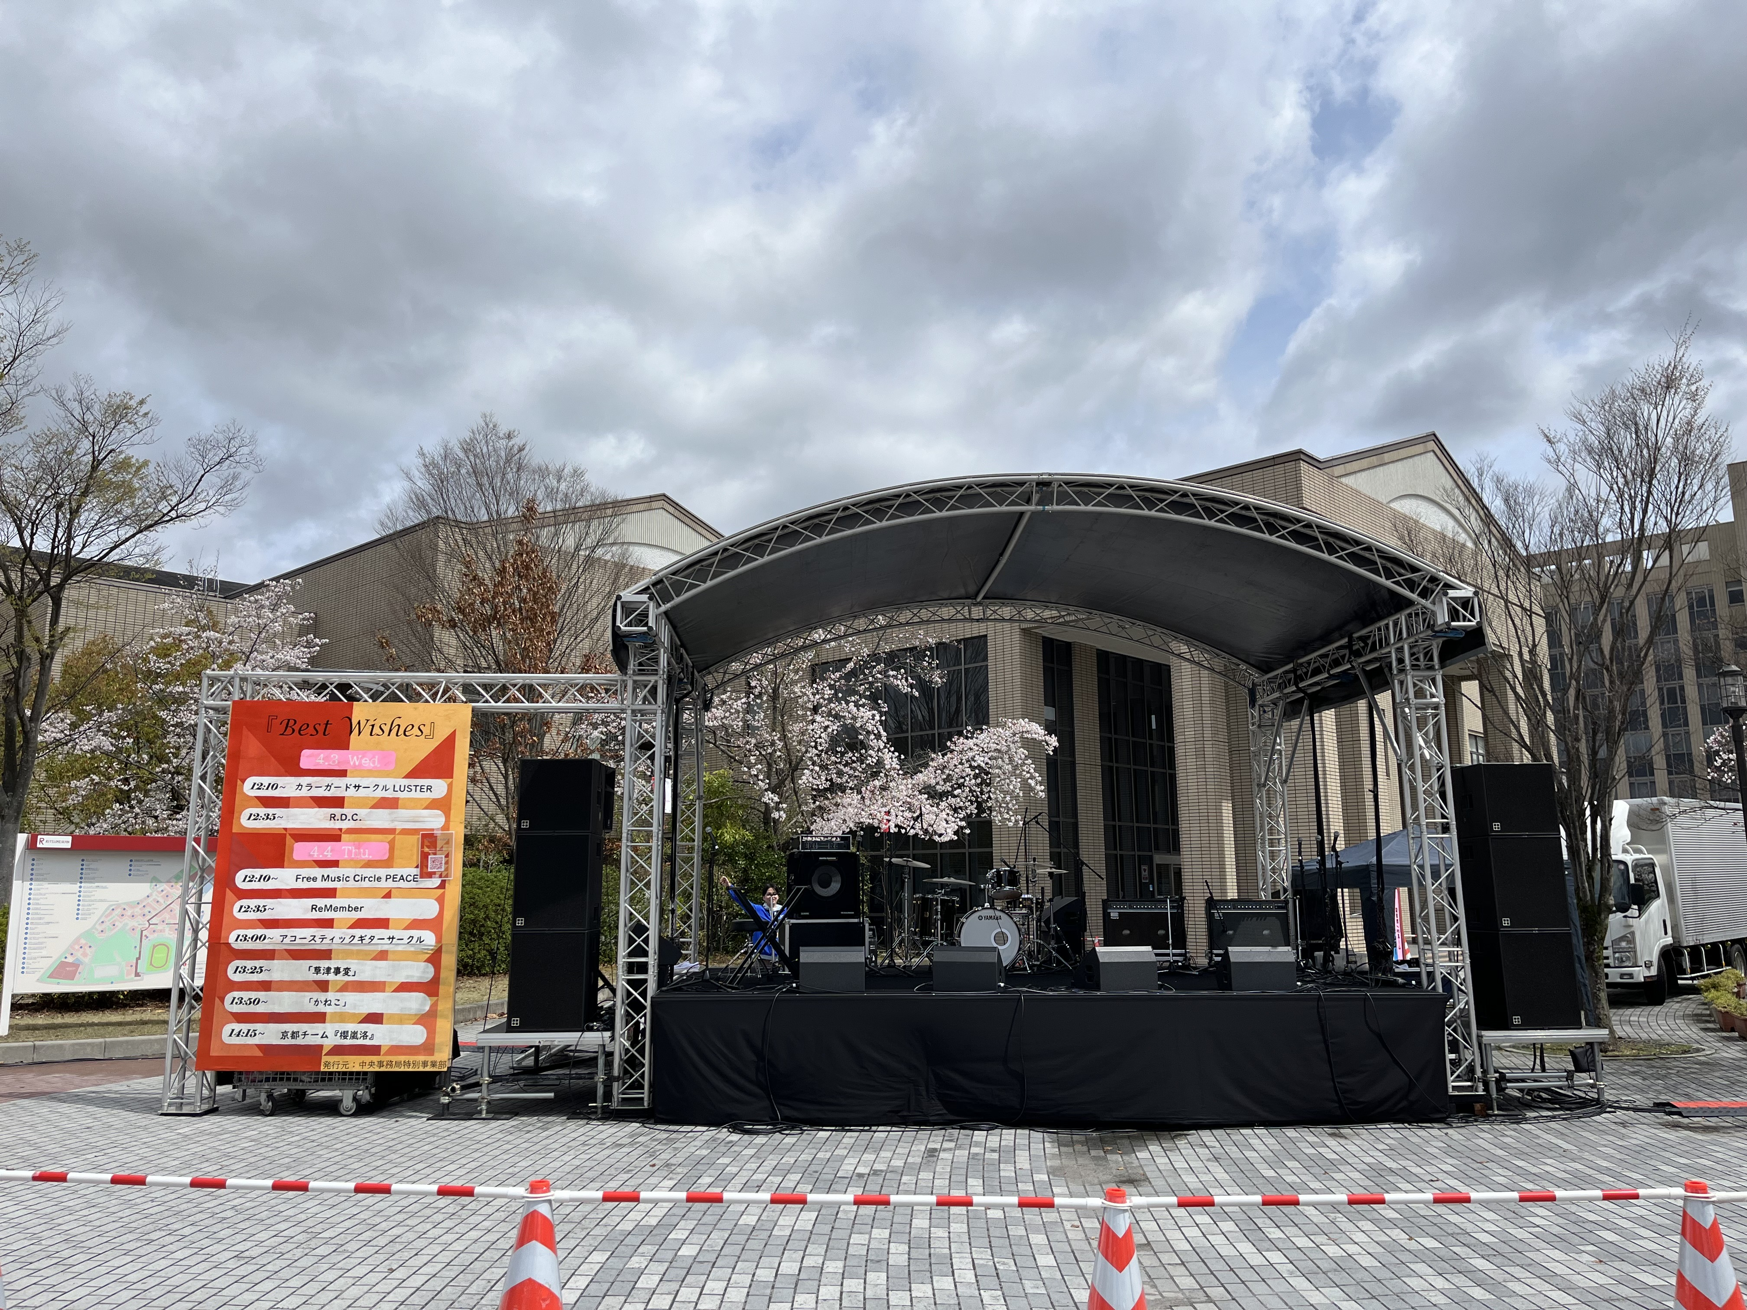

Table of Contents
- Regulations Concerning Personal Information Protection 4
- Stage Project Overview 6
- Prohibited Activities 8
- Performance Participation Process 8
- About reception 9
- Selection Process for Performing Groups 10
- Interview Process 11
Regulations Concerning Personal Information Protection
(Purpose)
Article 1
These regulations stipulate matters concerning the protection of personal information held by the University-wide Events Department (hereinafter referred to as "the Division") in its activities.

(Definitions)
Article 2
In these regulations, "personal information" refers to information that can identify an individual, such as the individual's name, address, date of birth, telephone number, email address, and student ID number.

(Responsibilities)
Article 3
The Division shall be responsible for complying with these regulations regarding personal information.

(Management Supervisor)
Article 4
The Director of the Division shall be appointed as the management supervisor for the protection of personal information within the Division.

(Security Management)
Article 6
The Division shall strictly manage personal information to prevent it from being viewed by third parties.

(Purpose of Use)
Article 7
The Division should use personal information only for the necessary tasks involved in planning and operating projects during the BKC New Student Welcome period.

(Disposal)
Article 8
The Division shall promptly dispose of personal information after the completion of all tasks specified in the preceding article.

(Provision to Third Parties)
Article 9
The Division shall not provide personal information to third parties.

Article 10
Notwithstanding the preceding article, the Division may provide personal information to third parties in any of the following cases:
①When consent has been obtained from the provider.
②When a request for disclosure of information related to a criminal investigation is made by the police, courts, or other authorities.
③When required by law.
Stage Project Overview
We are pleased to announce that the Freshman Welcome Stage Performance Event will be held at Central Circus again this year, following the success of last year's event. The scale of the stage will be comparable to that of the stage held at Being Square during the BKC Festival. We cordially invite you to participate in this exciting event.

Event Dates and Times:
Thursday, April 3, 2025, 11:55 AM – 1:15 PM
Friday, April 4, 2025, 11:45 AM – 1:25 PM

Rehearsal Date:
Wednesday, April 2, 2025, 10:00 AM – 6:00 PM
Please ensure that at least half of your performers attend the rehearsal.

Location: Central Circus
Stage Dimensions: 7m (width) x 6m (depth)
Performance Time: 10 minutes
Stage Transition Time: 10 minutes
Number of Participating Groups: 9 groups over 2 days

Layout
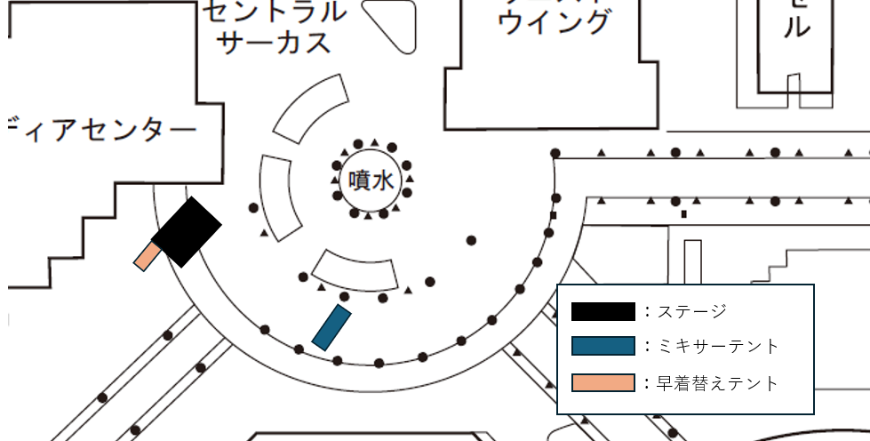

【Application Requirements】
- Applicants must be organizations affiliated with the Student Union.
- At least half of the performers must be students of Ritsumeikan University.
- The representative of the performing group must be a student of Ritsumeikan University.

【Regarding Performances During Inclement Weather】
As the stage is equipped with a roof, performances will generally proceed even in rainy conditions. However, in the event of severe weather conditions, such as heavy rain or strong winds, a decision to cancel the performance will be made through a joint assessment by the Event Planning Division, the New Student Welcome Event Committee, the Ritsumeikan Broadcasting Center (RBC), and the performers' organization. We appreciate your understanding in this matter. Depending on the nature of the performance and the timing of the cancellation decision, there may be instances where performances are partially or completely suspended.

【Confirmation of Performance Content by the Student Office】
The Student Office will review the performance content to ensure adequate safety measures are in place. Should any concerns arise during the Student Office's review, we will conduct hearings as necessary to determine the feasibility of the performance.
Prohibited Activities
- Defamatory or insulting remarks or actions towards others.
- Content of the presentation that violates public order and morals.
- Actions that violate laws and regulations.
- Damage or destruction of stage equipment or supplies.
- Any other actions or remarks that the University-wide Events Departmentdeems inappropriate.

* Violations of these provisions will result in strict measures, including compensation for damages and cancellation of stage performance participation. Your understanding is appreciated.

Performance Participation Process
- Registration
Please refer to page 8, "Registration Information," of this booklet for detailed instructions.
- Selection Audition and Announcement of Selected Groups
Please refer to page 9, "Selection Audition Information," of this booklet for detailed information.
- Interview
Please refer to page 10, "Interview Information," of this booklet for detailed information.
- Rehearsal
Rehearsal details will be provided during the interview.
- Performance

About reception
Application Period：Until 23:59, Saturday, March 8, 2025
Application Submission Location：2025 BKC Freshman Welcome Stage Performance Application Form
Number of Groups Accepted：9
Required Documents：
* Entry Sheet (PDF format)
* Performer List (PDF format)
* Pledge (PDF format)
* Electricity Usage Request (if applicable) (PDF format)
* Vehicle Entry Permit (if applicable) (PDF format)
* Hearing Sheet for Band Groups (from RBC) (PDF format)
* Hearing Sheet for Non-Band Groups (from RBC) (PDF format)
* Video Data Closely Resembling the Planned Performance (URL to video)
* Student ID Photos of All Performing Members (PDF format)
* Preferred Interview Dates (PDF format)
* Group Introduction Photo (Landscape orientation, JPG format)
* Personal Information Protection Agreement (PDF format)

※Important Notes※
* Please fill out all required information on the application forms and pledge and submit it via the application form provided on the cover page.
* If any performers are not Ritsumeikan University students, please submit a photo of their identification document in place of a student ID. Please note that the document must include a photo of the individual.
* Re-submission may be requested if the photos are unclear or incomplete.
* Please fill out all necessary information on the attached files and convert them to the specified formats before submitting them via Google Form.
Selection Process for Performing Groups
Performing groups will be selected through a selection audition process. Attendance by group members at the selection audition is not required. The content of the performances will be reviewed by the University-wide Events Department Stage Planning Staff and RBC.
* The Student Office will also review the performance content for safety and other considerations.

Date of Selection Audition
Monday, March 10, 2025

Evaluation Method:
The University-wide Events Department Stage Planning Staff and RBC Stage Staff will evaluate the submitted video data.

Evaluation Criteria
Total of 20 points
①Appropriateness of content for attracting new members (10 points)
②Completion of the performance (10 points)

Regarding Video Data Content
・Please ensure that the video data closely resembles the actual performance as much as possible.
・Please refrain from excessive editing of the recorded video.
・Please submit the video data via the application form.

Announcement of Selection Audition Results：Results will be announced sequentially from Monday, March 10th.
* Results will be communicated via email to the group representative and project leader.
* Notification of unsuccessful applications will also be sent via email to the group representative and project leader.
* Scoring results will not be disclosed. Your understanding is appreciated.

Interview Process
・Two meetings will be conducted with the University-wide Events Department Stage Planning Staff and RBC Stage Planning Staff to discuss the performance.
・The schedule will be based on the preferred dates provided during the application process.
・Attendance by both the group representative and the project leader is mandatory.
※The project leader for the stage performance cannot also be the project leader for the booth planning.
・If the scheduled times are absolutely inconvenient, please contact the email address provided for individual arrangements.

Dates
Round 1: Wednesday, March 12, 2025 – Saturday, March 15, 2025, 10:00 AM – 6:00 PM
Round 2: Sunday, March 16, 2025 – Wednesday, March 19, 2025, 10:00 AM – 6:00 PM

Format
Round 1: Primarily in-person (Zoom may be used if in-person attendance is impossible)
Round 2: Zoom

* As the first interview serves as an introductory meeting with the group representative and project leader, in-person attendance is preferred.
* The interview is crucial for the performance preparation. Participants are requested to join from a quiet environment and with their cameras turned on.

Items to be Confirmed During the Interview
・Performance content
・Interview content (to be used during MC transitions)
*Details will be sent via email upon announcement of selected groups.

Attachment
・For documents to submit, please use the files attached below.
*You can open the attached files from the recruitment booklet, which is in Word file format.
・When submitting, please convert each file to the specified file format and then submit via Google Forms.

・Required documents
or
*There are other files that must be submitted in addition to those listed above. Please see page 8 for details.

・Documents to be submitted as necessary

Google Form for submission is here：https://forms.gle/ozh8BTLPsvybGZAo8

