2024 University Festival Period
Group Events Recruitment Leaflet
OIC Edition
Event Date and Time: November 10, 2024 (Sun) 11:00-18:00
Event Venue: Ritsumeikan University Osaka Ibaraki Campus (OIC)
Recruitment Period:
【1st Recruitment】 July 15 (Mon) 14:00 – August 12 (Mon) 23:59
【2nd Recruitment】 August 13 (Tue) 0:00 – September 4 (Mon) 23:59

Publisher: Ritsumeikan University Student Union Central Administration Office University-wide Events Department
Table of Contents
p.2 About Group Events
p.4 Flow of Event Implementation
p.7 About Application
p.8 About Interviews
p.10 About Guidance
p11 How to Fill the Required Documents
p14 About Event Venue and Equipment
p.22 About Budget
p.26 About Bills
p.28 FY2024 Student Union Financial Aid Criteria
p.32 About Events with Revenue
p.35 About Events with Celebrities or Instructors
p.36 About Donations in Events
p.39 About Corporate Sponsorships
p.41 Corporate Sponsorship Guidelines
p.43 About the Handling of Personal Information

About Group Events

Group events have two objectives:
- Offering organizations a place to present their work and achievements to large audiences both from the university and outside and feel a sense of accomplishment.
- Entertaining many University Festival visitors through Group Events
We are looking for organizations that can achieve these two objectives.
■ Organizations eligible for group events
･ Ritsumeikan University Student Union Affiliated Organizations (excluding University Festival Executive Committee and Central Administrative Office)
･Other organizations run by undergraduate students of Ritsumeikan University, including seminars, laboratories, project groups, etc.
* The above are required to meet these two conditions as well:
- More than half the members are undergraduate students of Ritsumeikan University
- The event leader, vice event leader and event treasurer are undergraduate students of Ritsumeikan University

Additionally, group events are defined as the projects submitted by organizations to the University Festival Executive Committee, and group events are required to meet these conditions:
･ The event utilizes Ritsumeikan University facilities or equipment during the University Festival
･ The event presents the achievements of the organization’s usual activities directly to visitors

■ Organizations and events NOT eligible for group events
･ Events that may inflict physical harm to participants
･ Events that may damage university facility or equipment
･ Discriminatory expressions or events that can be identified as discrimination
･ Other events deemed inappropriate by the University Festival Executive Committee and University-wide Events Department
･ For-profit organizations (*the criteria for determining that an activity is not for profit is that there is no prospect of generating profit relative to the budget.)
･ Organizations that engage in antisocial behavior (illegal activities and actions that deviate from social common senses)
･ Organizations that promote or recruit new members to their religious or political ideologies
･ Organizations without event leader, vice event leader and treasurer

Flow of Event Implementation

- Preparation of required documents
Please download all the required documents from the Student Council website.

- Registration
After filling in the necessary information, please submit the required documents to the official LINE account.

- Interview with the University-wide Events Department
The interview consists of discussions between the University-wide Events Department and the organizations about the content, venue and budget of the event. Since it is necessary to confirm changes in project plans, communicate requests from the University-wide Events Department, report violations and explain the adjustment of facilities and equipment, we will conduct interviews twice per group in principle.

- Confirmation of the event
Implementing an event requires approval from the University Festival Executive Committee. When an event is rejected, changes regarding event contents may be suggested. It is only after the event is accepted by the Executive Committee that purchases of items and promotion of the event can be started.
※After the approval of the event, changes in contents or budget and cancellation of the event will not be permitted at all.
※Regarding budget assistance, it only applies to items purchased after the event has been approved. Please do not start purchasing until you receive notification that the project has been approved.
- Announcement of facilities and equipment available for use in each event
Once the facilities and equipment available for use in each project have been determined, we will notify the leaders of events.
※Regarding facilities and equipment, the Special Projects Department will handle the reservations, so there is no need for you to go through any application procedures.

- Guidance
To ensure the smooth progress of the project, we will provide guidance on the detailed schedule for the day, important precautions, prohibitions, and budget-related conditions.

⑦ Implementation of the event (IMPORTANT)
On the day of the school festival, please be mindful of the following violations. If an organization commits a violation during the preparations or implementation of the event, we may ask for the event to be cancelled or suspended based on the point deduction system outlined below.
【Point deduction system】
Each organization starts with 5 points, and if their points drop to 0, the event will be cancelled or suspended.
【1-point deduction】
･If eating or drinking (excluding beverages with lids) occurs at the event venue or in the waiting room.
･If equipment is left unattended at the project site during preparation or implementation.
･If marching or distributing flyers without possession of approval documents
･If a group of three or more individuals engages in marching or distributing flyers without possession of approval documents
･If deemed highly inappropriate by the University-wide Events Department and the University Festival Executive Committee
【3-point deduction】
･If the activity differs from what was confirmed in the event proposal or interviews
･If marching or distributing flyers without prior application
･If the organization distributes items other than the flyer applied for
･If engaging in nuisance activities that may lead to facility destruction
･If engaging in actions that cause inconvenience to other organizations or visitors
･If deemed extremely inappropriate by the University-wide Events Department and the University Festival Executive Committee
【5-point deduction】
･If engaging in acts of violence or causing significant harm to other organizations or the general public
･If damaging the university’s objects or facilities
･If earning income other than with tickets designated by the University-wide Events Department without prior application
･If deemed extremely inappropriate by the University-wide Events Department and the University Festival Executive Committee

About Application
■ Registration period
1st Recruitment： July 15 (Mon) 14：00 – August 12 (Mon) 23：59
2nd Recruitment： August 13 (Tue) 0：00 – September 2 (Mon) 23：59

■ Registration Location： Submit documents via official LINE.
Please note that we do not accept submissions outside the reception period.
Please confirm that there are no mistakes in the required documents before submission.

※If you wish to organize an event at KIC or BKC, please refer to the recruitment booklet for each campus.
※Organizations wishing to participate in stage events held on the SORA-NO-Plaza should refer to the stage event recruitment booklet and apply accordingly.

About Interviews

We will conduct meetings between the University-wide Events Department and the organization regarding event details, venue, equipment usage and budget. The meetings are conducted twice per organization in principle. Please indicate your preferred dates and times for interviews in your event proposal.

☆Interview dates and times (both session 1 and 2 are planned to take about 20-30 minutes)
1st Recruitment
Session 1: August 23 (Fri) – August 25 (Sun) 11:00-18:00 for all dates
Session 2: August 30 (Fri) – September 1 (Sun) 11:00-18:00 for all dates
If the dates mentioned above are all inconvenient for you, we have set backup dates: for Session 1, August 26 (Fri) and for Session 2, September 2 (Mon).
2nd Recruitment
Session 1: September 6 (Fri) – September 8 (Sun) 11:00-18:00 for all dates
Session 2: September 13 (Fri) – September 15 (Sun) 11:00-18:00 for all dates
If the dates mentioned above are all inconvenient for you, we have set backup dates: for Session 1, September 9 (Mon) and for Session 2, September 16 (Mon).
※If you wish to use the backup dates, please indicate your preference.
☆Interview participants
Event leader and event treasurer (substitution attendance is accepted)
※If the budget is 0 yen, the event treasurer is not required.
※If the event leader or event treasurer cannot attend the interviews, we allow a substitute who sufficiently understands the event details to attend. Alternatively, we can arrange a separate interview on another day. If a substitute will attend, please inform us via official LINE by the previous day.
☆Interview method
Interviews will be conducted on Zoom. We will inform the event leader and event treasurer via official LINE by the previous day.
※If you cannot join the Zoom meeting on time or technical difficulties happen with Zoom, please contact the University-wide Event Department.
※If you plan to organize an event on multiple campuses → Interview methods differ for each campus. Please refer to the recruitment booklet for each campus.

About Guidance

To ensure the smooth progress of the project, we will provide detailed guidance on the flow of the festival, important notices, prohibited actions, and budget-related conditions.
As this is a crucial guidance to have before the festival, it will be conducted in-person.
Date and Time: October 10 (Thur) or October 11 (Fri) 18：00～20：00
Please attend one of the two sessions.
Format: in-person (location will be provided at the interview)
Participants: Event leader and event treasurer
(If they cannot attend, a substitute who sufficiently understands the event can attend)
※If a substitute will be attending, please inform us of the situation by the previous day.
※If even the substitute cannot attend and you are going to be absent from the guidance, we will arrange an individual session at the Student Lounge, 3rd floor of Building A at a later date. If this is the case, please inform us that you will be absent and your preferred date of the individual session by a day before the guidance via official LINE.

How to Fill the Required Documents
They are documents for communicating to us what kind of events each organization will hold. Please provide as much details as possible.
- Event Proposal (Word)
Official Name of the Organization | Please fill in the official name of the organization. Please be careful of the details, such as if it has “Ritsumeikan University” or upper/lower case of the alphabets.
Organization Categories | Please tick the category the organization belongs to.
Information of Leaders | Only students of Ritsumeikan University can be event leaders, vice event leader and event treasurer. Event treasurers cannot hold multiple positions, including positions for other events.
Event Name | Please name the event appropriately.
Event Purpose | Please provide the purpose of the event with details.
Target number of visitors | Please provide the number of visitors you aim to attract to your event.
Event Format | Please tick the format the event uses.
Event Content | Please provide the content of the event with as much details as possible. If you have a timetable, please include it as well. If you are performing songs, please provide the name of the songs. If the content is significantly different from what was confirmed on the interview, the event can be cancelled.
Layout Plan | Please include diagrams or illustrations to indicate where members will be, the positioning between the members and visitors and equipment positions in the event. Please plan assuming you can use the facility of your first choice. Please also provide the number of members who will always be on the venue.
Preparation schedule/timetable | Please provide detailed preparation schedule up to the festival day and the timetable from the start of the festival to the cleaning up.
Event Revenue | Please indicate if your event generates cash revenue If so, please set the price and the number of customers. Please estimate the revenue, assuming all the set customers will buy the product. Please make sure that the estimated revenue does not exceed the expenditure of the event (events with profit are not accepted).
Donation | Please indicate if you would like to donate. If choosing “Yes”, please fill in the Sheet for Donation.
Corporate Sponsorship | Please indicate you are affiliated with a corporation. When choosing “Yes”, please fill in the Application Paper for Corporate Sponsorship and Corporate Sponsorship Agreement.
Promotion Method | Please provide the promotion method for before and on the festival day.
Handling of Personal Information | Please read the Terms and Conditions about Personal Information and indicate if you agree or disagree.
Commitment Letter | Please fill in the required fields.
Preferred Venue | Please indicate your first to third choices.
Preferred Waiting Room | Please fill in only if you would like to use a waiting room.
Equipment Request | Please indicate if you would like to use university equipment and if using, specify the desired equipment.
Dolly and Ladder Request | Please fill in only if you would like to use a dolly or a ladder.
Electricity Request | Please fill in only if you would like to use electricity.
Vehicle Entry Request Form | Please fill in only if you would like to use vehicle entry.
FY2024 University Festival Group Event Vehicle Entry Request Form | Please fill in only if you would like to use vehicle entry.
Corporate Sponsorship Request Form | Please fill in only if you would like to use corporate sponsorship.
Corporate Sponsorship Commitment Letter | Please fill in only if you would like to use corporate sponsorship.

- List of Event Members (Excel file)
Please provide the information of all the members involved with the event.

- Budget Estimate Worksheet (Excel file)
Please provide Category, Item, Price, Amount, and Total Estimated Budget.
For Category, please refer to the FY2024 Student Union Investment Criteria Chart on page 29. For Price, please provide the tax- included price.
After filling in everything, please provide the total estimated budget in the Total section.

- Form for 2024 Ritsumeikan University Festival Brochure (Word)
Please provide these entries, which will be on the University Festival Brochure:
･Name of the Organization
･Theme and Title of the Event (no more than 40 alphabet letters)
･Description of the Event (no more than 200 alphabet letters)
･Time of the Event
･Photo

About Event Venue and Equipment

On the day of the University Festival, many events will be implemented, which may lead to potential overlaps in the use of locations and equipment among various events. Therefore, to prevent conflicts and ensure the smooth operation of the University Festival, the University-wide Events Department will manage and coordinate all locations and equipment from the day before the festival until the day of the event.
- Flow until Announcement of Event Venue and Available Equipment
- Registration
We will coordinate event venues and equipment based on the documents you submit. Please carefully confirm the number of desks, chairs, whiteboards and other equipment available in the facilities you wish to use and indicate the required number of event venues and equipment.

- Interview
We will confirm detailed event information and your desired venues and equipment.

- Determination of Event Venues
In case of overlapping requests, event venues will be determined through a lottery system. However, based on your preferences and the details provided during the interview, the University-wide Event Department may assign a different venue.
※After determining event venues and equipment, there may be requests from the university or the University-wide Event Department to change the venue or timing of your event due to university events or regular classes. Also, delays in announcements may occur for equipment or facilities that are difficult to coordinate. Thank you for understanding.
- About Event Venues and Waiting Rooms
- Available Locations
Classrooms in Building A (2nd and 3rd floor, AS and AC side only), Building D Student Hall, JIZAIHALL, Wakebayashi International Plaza
※In OIC, events are held in buildings in principle.
※If you would like to use the stages, please refer to the Stage Event Recruitment Booklet.
② Facility Use Hours
※The available hours for the waiting rooms are the same as the facility’s operating hours.
 | 9-10 | 10-11 | 11-18 | 18-19
Building A Classrooms | Preparation Accepted | Preparation Accepted | Preparation, Event, Cleaning Accepted | Cleaning Accepted
Building D Student Hall | Preparation Accepted | Preparation Accepted | Preparation, Event, Cleaning Accepted | Cleaning Accepted
Building H  JIZAI HALL | Preparation Accepted | Preparation Accepted | Preparation, Event, Cleaning Accepted | Cleaning Accepted
Wakebayashi International Plaza |  | Preparation Accepted | Preparation, Event, Cleaning Accepted | Cleaning Accepted

※Please provide accurate hours of event and preparation in the Event Proposal.
※If you wish to prepare on the day before or outside the specified hours above, please indicate your interest in the proposal and provide reasons. While we cannot guarantee accommodation for all requests, we will consider them during venue allocation and scheduling.

- Important Notices
When choosing the venue and waiting room, please make sure to refer to the online Campus Map (http：//www.ritsumei.ac.jp/campusmap/) and Floor Guide (https：//www.ritsumei.ac.jp/file.jsp?id=229844&f=.pdf).
After the event, please clean up the venues and waiting rooms thoroughly. Classrooms can be used for lectures, so make sure to return everything to its original condition (chairs, desks, equipment, etc.).
The organizations are fully responsible for any damage to facilities or equipment incurred during the implementation of the event. The Univeristy-wide Events Department assumes no responsibility.
We do not keep valuables; please make sure to manage them with utmost care. The University-wide Events Department will not bear any responsibility.

④ Prohibited Actions
If you violate the following prohibitions, your event may be cancelled, and you may face severe penalties from the University Festival Executive Committee and the university. Penalties may also be imposed if violations are discovered after the project ends.

• Damage to indoor facilities such as painting, walls, ceilings, or causing flooding
• Use of open flames
• Use of adhesive tapes or materials that leave marks on walls, glass, doors, ceilings, etc. (If tape is necessary, please use protective or masking tape. Other types of tape are not allowed.) *The use of protective or masking tape at Wakebayashi International Plaza will be explained during interviews.
• Damage to or unauthorized removal of desks, chairs, or other provided equipment
• Consumption of food or drink unrelated to the project or without permission
• Unauthorized use of electricity (including charging mobile phones)
• Unauthorized use of facilities
• Changes to project time, facility use time, or project location without permission
• Actions unrelated to the project
• Excessive noise beyond specified limits
• Any other actions deemed dangerous by the Special Projects Division
- About Equipment

- Available Equipment
･Available in Building A, D, H and Wakebayashi International Plaza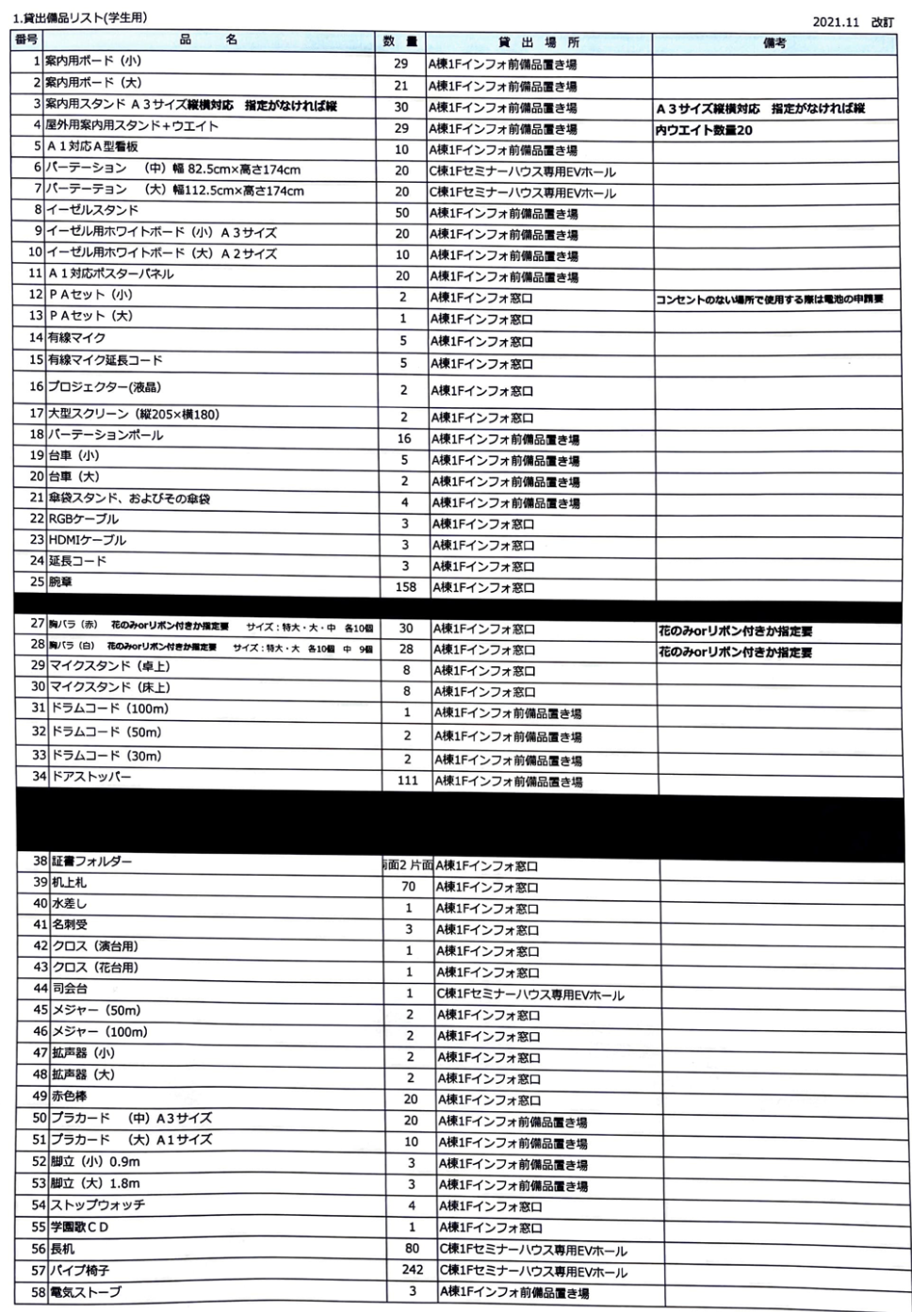
If you would like assistance with the chart, please contact the University-wide Events Department.
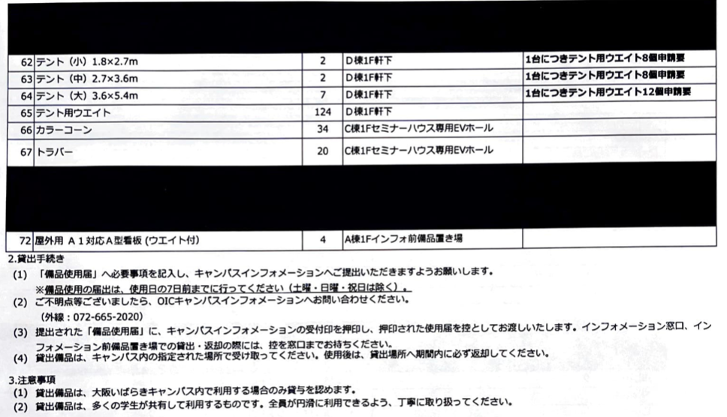
If you would like assistance with the chart, please contact the University-wide Events Department.
※The list includes the equipment in use. Please note that not all equipment is available.
※If you are unsure of any items on the list, please ask us in the first interview.

･If using Building D Student Hall
If you would like assistance with the chart, please contact the University-wide Events Department.

･If using Building G Wakebayashi International Plaza
Item | Quantity
LCD screen (with code) | 3
Whiteboard (movable) | 1
Projector (unmovable) | 2
Whiteboard (unmovable) | 1

※If you would like to use these equipment, please indicate your interest in the Proposal and during the first interview.
※Due to limited quantities of equipment, please submit your request for the minimum necessary number.
- Lending of Ladders and Dollies
Due to the limited number of ladders and dollies compared to the number of requesting groups, we operate on a shift-based lending system to accommodate as many groups as possible. We appreciate your understanding and cooperation.
- Use of Facility-Provided Equipment
You are free to use the equipment provided in each facility (desks, chairs, blackboards, lecterns, projectors, etc.). If you need to move desks or chairs within the facility, please inform us during the interview.
- Important Notices
On the day of the OIC festival, due to the implementation of many projects, it may not be possible to use all the requested equipment.
Adjustments for highly requested on-campus equipment (such as curtains, partitions, projectors, PA sets, etc.) may be difficult, and may not align with each group's preferences. It is also possible to order from external suppliers, but this incurs usage fees. Please consider this possibility when applying for equipment.
There is a limited quantity of equipment available. Using a large quantity of equipment for one project may make it difficult for other events to be implemented. Please carefully estimate the necessary equipment to ensure that the estimated equipment is used on the day of the event.
When placing heavy equipment on indoor desks or school-provided equipment, please use a cloth to prevent damage to the tabletop.
- Electricity Usage
If your project requires electricity, please fill out the "Electricity Usage Request" form with the necessary details and submit it.
*Please note that depending on the electricity usage on the day, it may not be available for your use.
*Private use of electricity for activities such as charging mobile phones is not permitted.
- Vehicle Entry
Vehicle entry at OIC is generally prohibited. If vehicle entry is absolutely necessary for loading and unloading, please fill out the necessary details on the submission form and submit it. Unauthorized vehicle entry is strictly prohibited.
About Budget
〇Introduction
Please fill out the "2024 Ritsumeikan University Festival Group Project Budget Estimate Worksheet" with the necessary expenses required for your project. Regardless of whether financial aid is provided, submission of both the budget estimate worksheet and the post-project financial statement is mandatory. Changes regarding financial aid availability after project approval are not permissible.
〇Financial Aid
If your project is approved, financial aid can be granted from the student council fees. Even if similar projects are conducted in other campuses, separate requests for financial aid for each project item are required. Please note that this differs from the previous fiscal year.
〇Student Union Fees
Student union fees are collected from all Ritsumeikan University students as financial support for extracurricular activities.
〇Aid Amount
Financial aid will be provided for up to 40% of the approved budget deemed eligible for disbursement. The maximum aid limit is 150,000 yen.
Example 1: If the required expenses amount to 50,000 yen
The aid provided will be 20,000 yen (40% of 50,000 yen)
Example 2: If the required expenses amount to 300,000 yen
The aid will be capped at 150,000 yen

○Criteria for Student Union Fee Aid
①Suitability for the festival
➁Appropriateness of the proposed costs
③Compliance with the FY2024 Student Union Fee Aid Criteria (page 29)
④Accuracy and appropriateness of the budget estimate
These criteria will be reviewed during the interview.

○Necessary Expenses
Refer to page 29 of the " FY2024 Student Union Fee Aid Criteria " for eligible items. Expenses unrelated to the project or with unclear budget estimates will not be considered.

○Budgeting Process and Worksheet Instructions
①Conceptualize your project. Clearly define the intent, content, scale, location, and target audience of your project.

➁Identify required items. List all items needed, including those to be borrowed from the university, rented at a cost, or purchased outright. Ensure nothing is overlooked.

③Research prices.
※ Research and document the prices of required items. Whenever possible, obtain multiple quotes and consider cost balance when choosing suppliers. Avoid websites prone to price fluctuations; if unavoidable, purchase from reliable sources like Asukuru.
④Referencing the FY2024 Student Union Fee Aid Criteria. Use page 29 of the criteria to categorize expenses accordingly.

⑤Complete the Budget Estimate Worksheet. Include columns for "Category," "Item," "Unit Price (tax included)," "Quantity," "Estimated Total," and "URL or photo data showing item prices." Tax-inclusive prices should be recorded.

⑥Referencing the FY2024 Student Union Fee Aid Criteria (page 29), fill in the necessary expenses for categories eligible for the aid.

➆After filling in everything, fill out the Total section with the estimated total budget.

⑧Submit the Worksheet with the Proposal to the Univerisity-wide Events Department.

⑨The budget will be confirmed at the interview. Please bring proof of the price when purchasing products from shops other than the Seikyo.
※If there are oversights at the above-mentioned stages, there will be a possibility that the events may not come to fruition. Please confirm each entry carefully.

○Purchasing Items
It is only after the approval of the event that you may purchase the necessary items. We will notify you when the event is approved.
※No aid will be provided to items purchased before the approval under any circumstances.

About Bills

- Please have the addressee written as "Ritsumeikan University Student Union University Festival Executive Committee."
- The date, issuer, and issuer's seal must be clearly stated.
- Check if the purchase items (each item name), unit price, and quantity are all listed.
- Please confirm that the total amount is correct.
- In previous years, receipts with the organization name as the addressee have been submitted. Please be careful when filling it out.
- If there are any deficiencies in the receipt, please have the store that issued the receipt make corrections. Do not make corrections yourself under any circumstances.
- Please note that items without a receipt or that do not comply with the above instructions cannot be supported financially. Please be cautious.
e.g.)
領収書
立命館大学学友会学園祭実行委員会 様
2024年○月×日(△)
¥7600
但し A4コピー用紙 ¥380×20
生協 ㊞
If you would like assistance with the chart, please contact the University-wide Events Department.

○Regarding the settlement
• If you are receiving budget assistance, it is necessary to attend the accounting guidance conducted by the Central Office Finance Department. Both the project leader and the accounting manager must attend. Details of the guidance will be communicated during the interview.

• If you are absent from the guidance without permission, budget assistance will generally be discontinued.

• Insurance required for the project is included in necessary expenses.

• Estimates from vendors (such as vendors) must be submitted during the interview.

• Some vendors may take time to provide estimates, which may not align with the project approval date. In such cases, the corresponding amount will not be recognized as part of the budget and will not be applicable during settlement. It is recommended to request estimates from vendors promptly.

• If you are absent without permission from the accounting guidance conducted by the Central Office Finance Department, withdrawals will be discontinued at that time.

• If you have any questions regarding budget and settlement, please contact the Central Office Finance Department at Student Hall 2F B207, 075-465-8251, or info@r-circle.net

FY2024 Student Union Financial Aid Criteria
Consumables Cost | Eligible
Books Cost | Eligible
Postage Fee | Eligible
Transportation Fee | Eligible
Print Fee | Eligible (Vendor contracts require approval from the University Festival Executive Committee)
Usage Fee | Eligible
Insurance Fee | Eligible
Transaction Fee | Eligible
Labor Costs | Inside the university: 5000 yen maximum per person  Outside the university: requires approval from the University Festival Executive Committee
Union Fee | Ineligible
Lodging Fee | Ineligible
Equipment Fee | Ineligible
Maintenance Costs | Ineligible
Other costs | Ineligible

<FY2024 Student Union Fee Categorization>
Consumables Cost | Consumables and office equipments in general  *PPC paper, envelopes, drawing paper, strings for arts and crafts, masking tape, parts, lime for athletic clubs, flies, etc.
Books Cost | Books, CDs, DVDs, etc.  *Specialized books, newspapers, periodical publications, maps, sheet music, etc.
Postage Fee | Communication expenses, postage fees, postage.  *Telephone charges, postal charges, mail postage, postcards, stamps, etc.
Transportation Fee | Transportation expenses and hauling costs.  *Funds necessary for the movement of people and goods within activities, including shuttle bus tickets, public transportation, taxis, and trucks for transportation purposes.
Print Fee | Printing expenses related to materials issued by the organization externally.  *Copy cards, internal copies, vendor-contracted flyers, photo fees, etc.
Usage Fee | Fees for using facilities or rentals.  *Facility, rentals, copy rights, tickets, rental cars, etc.
Insurance Fee | Insurances related to the ecent  *Recreation insurances, etc.
Transaction Fee | Transaction expenses.  *Transfer fees, cash on delivery fees, etc.
Labor Costs | Labor costs in general  *Lecturers, accommodation expenses, transportation expenses etc., for inviting lecturers and similar individuals.
Union Fee | Fees paid for unions  *Union participation fees (contributions), participation fees, tournament advertising expenses, pamphlets, etc.
Lodging Fee | Lodging fees.  *Lodging fees, training camp fees, seminar house lodging expenses
Equipment Fee | Equipment in general  *An item will be considered consumables if it costs less than about 10,000 yen or the nature of the item is consumable  *PC-related equipment, shredders, racks, desks, etc.
Maintenance Costs | Expenses for repairing or maintaining equipment  *Cleaning fee, repairment fee for musical instruments (the cost of repairs fur to damage to rented items is classified as Other costs)
Other costs | Fees related to personal activities, rather than an organization  * Medicines, play equipment, food and beverages (including water, sports drinks, and tea snacks), items related to ceremonies (such as weddings and funerals), cosmetics, and uniforms for uniforms

About Events with Revenue
○ Introduction
Group events are intended for presenting the regular activities of organizations and students, and commercial purposes are not permitted. If income such as entrance fees is generated during the planning process, please record it in the designated section of the project proposal and report it to the University-wide Events Department without fail. If income is generated without prior approval from the University-wide Events Department, you must immediately suspend the project.

※ Please use the revenue only for the operation of the event. Profit generated that can be used for purposes other than this year's university festival event is not permitted.

○Method for generating revenue
If revenue is generated within the event, only ticket sales will be permitted.
※Application is needed for any changes in price or amount sold of the ticket.
※Do not reuse tickets from the previous year or before.
To generate revenue, these processes are necessary. If you organize an event with profits, the event will be cancelled immediately.

○Process
①Consultation with the University-wide Event Department (interview)
The pricing, quantities, and other details will be determined through hiring, referencing the event content, budget estimate worksheet, and budget estimate sheet.

②Making Tickets
After approval through the interview, please create (or order) tickets. The ticket size should be at least 4cm tall by 10cm wide. There are no specific design requirements, but please ensure the design adheres to public order and morals.

③Approval of the tickets
Please bring a quotation with the created tickets, the number issued, and their prices to the University-wide Event Department. Please number all tickets. The University-wide Event Department will stamp them with an audit seal after verification.

④Process Completion
The tickets will be returned to the organization after the reviewing process.

○About Selling Items
There are items permitted to be sold at events. Please contact us for any questions.

<Items that can be sold>
Items that will enhance the event content by means such as deepening visitors’ understanding of the event content.

<Items that cannot be sold>
Items unrelated to the organization.

About Events with Celebrities or Instructors
In the university festival period group events, the organizations are permitted to invite celebrities or instructors only if it is deemed necessary to convey the group's activities.
This may involve complex tasks and required knowledge such as the following:
- Trouble management
- Negotiation of appearance fees
- Important notices about the contract
- How to sign a contract
- Creating security plans

※Projects that seek to invite celebrities or instructors without valid reasons may not be approved, as there is a possibility that they could undermine student initiative.
※If negotiations with celebrities or instructors begin and the project is subsequently not approved, there is a risk of facing penalties for breach of contract from the other party. Therefore, consider carefully whether inviting presenters or instructors is truly the most effective way to maximize your group's appeal and convey what you aim to achieve through the project. Plan accordingly with these considerations in mind.

About Donations in Events
In this page, precautions for conducting fundraising activities within projects are described. Organizations planning fundraising initiatives are kindly requested to read this carefully.
【Organizations that can carry out donations】
･Organizations conducting fundraising activities as part of their regular operations
･Organizations with clear objectives, activities, responsible persons, locations, and contact information
･Organizations that disclose information such as activity reports and financial statements
【Purpose for donations】
･It relates to the organization's activities and is part of the introduction of those activities.
･It is not directed towards specific individuals or for profit-making purposes.
【Donation destinations】
･An organization with clear objectives, activities, responsible persons, location, and contact information.
･An organization that discloses information (activity reports, financial statements).
【Things that fundraising organizations must do when conducting fundraising】
･Introduction of the purposes and activities of the fundraising organization (including the recipient organization).
･Explanation of the fundraising objectives and the intended use of the collected funds.
･Introduction of the purposes and activities of the intermediary organization if acting as a fundraiser.
･Reporting of the total amount raised and donation recipients using websites or other platforms.
･Independent accounting and full donation of all collected funds.
･Presentation of a certificate or equivalent document stating that the recipient accepted the remaining donation funds, for use by the University Festival Executive Committee.
【Prohibited actions for fundraising organizations】
･Soliciting donations outside designated areas
･Fundraising aimed at promoting antisocial activities
･Behavior that appears to coerce donations
･Other actions deemed inappropriate by the University-wide Events Department, University Festival Executive Committee, or Student Affairs Department
【Responses during fundraising implementation】
The University-wide Events Committee will initiate following actions for fundraising organizations.
●Before the event approval
Confirmation that the organization's objectives and activities are appropriate, and that the planned fundraising complies with the above provisions.
●After the event approval
･Confirming the publicity materials and exhibits containing explanations about the fundraising.
･Issuance and responsibility for displaying fundraising permits under the name of the University Festival Executive Committee, around the fundraising boxes.
･Confirmation of the fundraising amount between the fundraising organization and the University Festival Executive Committee after fundraising
･Creation of a confirmation document with stamps from both the fundraising organization and the University Festival Executive Committee after confirming the above fundraising amount, and thorough storage of the confirmation document.
･Mandatory submission of copies of certificates issued by the donation recipient and bank transfer certificates at the time of settlement.
※However, the University Festival Executive Committee shall not be held responsible in case of problems arising from the intentional or negligent actions of the fundraising organization preventing the completion of the fundraising.

About Corporate Sponsorship
Corporate sponsorship refers to the support provided by external organizations or companies to student-led initiatives in the form of necessary funds or goods. Major forms of corporate sponsorship include creating banners or pamphlets, obtaining sponsorship fees, or acquiring prizes. However, extracurricular activities are platforms for students' voluntary initiatives and not venues for commercial activities.
Therefore, when seeking corporate sponsorship for projects, promotions, or other activities related to extracurricular activities, approval is granted by the University-wide Events Department only after careful review, ensuring that it is necessary and appropriate. If you wish to seek corporate sponsorship for your project, please read the "Corporate Sponsorship Guidelines" on the next page carefully and submit the "Corporate Sponsorship Application Form" and "Corporate Sponsorship Agreement" along with other necessary documents to the University-wide Events Department at the time of application.
.※University-wide Events Department will not be responsible for any issues between the sponsorship corporation and organizations.
▼ Process of Corporate Sponsorships
1､Please carefully review the "Corporate Sponsorship Guidelines" on the following page.
2､Fill out the "Corporate Sponsorship Application Form" and "Corporate Sponsorship Agreement" sections in the "2024 School Festival Period Group Project Proposal." Submit the completed "2024 School Festival Period Group Project Proposal" at the group project reception.
3､Submit samples of promotional materials containing corporate advertisements to be published by the deadline and samples of prizes to be distributed as sponsorship items via official LINE to the Special Projects Division.
4､The Special Projects Division will check the submitted samples for compliance.
5､Corporate sponsorship will be allowed only if the project is approved and sponsorship is permitted.

Corporate Sponsorship Guidelines
〇Conditions
The stipulated conditions regarding corporate sponsorship are defined as follows, within the scope of correctly conducting project promotions without compromising project content

【Sponsorship benefits available to organizations】
●Fees for creating banners or pamphlets for the project
●Provision of prizes for use in the project, such as gifts
●Free borrowing or provision of items for use in the project
●Provision of funds for project operation
●Technical sponsorship other than the above

【Actions corporations can take as sponsorship】
●Public disclosure of the corporation's name
Display of the corporation's name on posters, banners, pamphlets, websites, and social media, etc.
●Introduction of the corporation in the project
However, the introduction of the corporation is limited to students affiliated with the organization.
●Display of prizes used or distributed in the project
●Advertisement placement in banners, flyers, etc.

【Actions corporations cannot take as sponsorship】
●Commercial activities for profit-making purposes
Sale of goods or contract activities within campus premises, etc.
●Participation of corporate personnel in the project for advertising or promotional purposes

About the Handling of Personal Information
(Purpose)
Article 1
This regulation aims to protect the personal information acquired by the Special Projects Division (hereinafter referred to as "the Division") in its activities.

(Definitions)
Article 2
In this regulation, "personal information" refers to information that can identify individuals, such as name, address, date of birth, telephone number, email address, student ID number, etc.

(Responsibilities)
Article 3
The Division shall bear responsibility for complying with this regulation regarding the protection of personal information.

(Manager in Charge)
Article 4
The Director of the Division shall be appointed as the manager responsible for the acquisition of personal information protection within the Division.
Article 5
The manager in charge shall guide and supervise Division members to comply with this regulation.

(Security Management)
Article 6
The Division shall strictly manage personal information to prevent it from being accessed by third parties.

(Purpose of Use)
Article 7
The Division shall use personal information only for necessary tasks related to planning and operating events or projects during the festival period.

(Disposal)
Article 8
The Division shall promptly dispose of personal information once all tasks specified in the preceding article have been completed.

(Provision to Third Parties)
Article 9
The Division shall not provide personal information to third parties.
Article 10
Notwithstanding the preceding article, the Division may provide personal information to third parties in the following cases:
1. When consent is obtained from the provider.
2. When requested by the police, court, or other investigative authorities for disclosure of information related to criminal investigations.
3. When required by law.

Publisher: Ritsumeikan University Student Union Central Administration Office University-wide Events Department

